1. Which characteristic is shared by all prokaryotes and eukaryotes?
   1. Ability to store hereditary information
   2. Use of organelles to control cell processes
   3. Use of cellular respiration for energy release
   4. Ability to move in response to environmental stimuli
2. Living organisms can be classified as prokaryotes or eukaryotes. Which two structures are common to both prokaryotic and eukaryotic cells?
   1. Cell wall and nucleus
   2. Cell wall and chloroplast
   3. Plasma membrane and nucleus
   4. Plasma membrane and cytoplasm
3. Alveoli are microscopic air sacs in the lungs of mammals. Which statement BEST describes how the structure of alveoli allows lungs to function properly?
   1. They increase the amount of energy transferred from the lungs to the blood.
   2. They increase the flexibility of the lungs as they expland during inhalation.
   3. They increase the volume of the lungs, allowing more oxygen to be inhaled.
   4. They increase the surface areas of the lungs, allowing efficient gas exchange.
4. Which statement BEST describes an effect of the low density of frozen water in a lake?
   1. When water freezes, it contracts, decreasing the water level in a lake.
   2. Water in a lake freezes from the bottom up, killing most aquatic organisms.
   3. When water in a lake freezes, it floats, providing insulation for organisms below.
   4. Water removes thermal energy from land around the lake, causing the lake to freeze.
5. Which statement correctly describes how carbon’s ability to form four bonds makes it uniquely suited to form macromolecules?
   1. It forms short, simple carbon chains.
   2. It forms large, complex, diverse molecules.
   3. It forms covalent bonds with other carbon atoms
   4. It forms covalent bonds than can exist in a single plane
6. Carbohydrates and proteins are two types of macromolecules. Which functional characteristic of proteins distinguishes them from carbohydrates?
   1. Large amount of stored information
   2. Ability to catalyze biochemical reactions
   3. Efficient storage of usable chemical energy
   4. Tendency to make cell membranes hydrophobic
7. A scientist formed Chemical X in a laboratory. The material was then analyzed by other scientists. Analysis showed that the chemical was composed of long chains of repeated CH2 molecules.

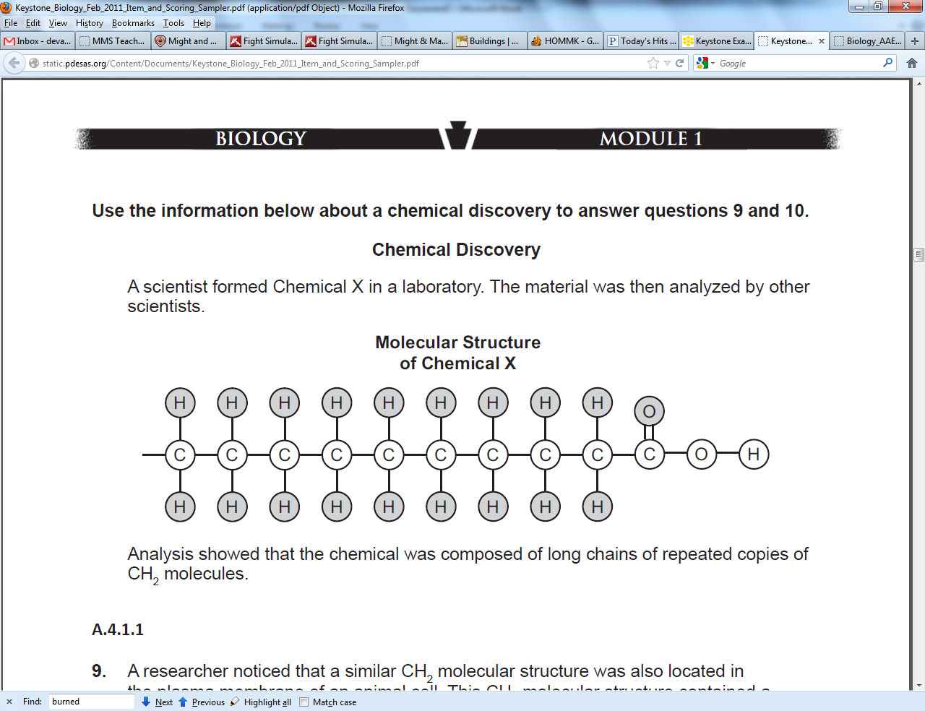

A researcher noticed that a similar CH2 molecular structure was also located in the plasma membrane of an animal cell. The CH2 molecular structure contained a negatively charged phosphate groups. Which statement BEST describes the primary function of the CH2 and phosphate molecular structure located in the plasma membrane?

1. It contains the genetic information needed for protein production.
2. It allows the energy that a cell needs to perform various life processes.
3. It allows a cell to regulate the movement of materials into and out of a cell.
4. It catalyzes specific chemical reactions in the cytoplasm of a cell.
5. Which type of organic molecule was MOST LIKELY formed by the scientist in the laboratory?
   1. Lipid
   2. Protein
   3. Carbohydrate
   4. Nucleic acid
6. Substance A is converted to substance B in a metabolic reaction. Which statement BEST describes the roles of an enzyme during this reaction?
   1. It adjusts the pH of the reaction medium.
   2. It provides energy to carry out the reaction.
   3. It dissolves substance A in the reaction medium.
   4. It speeds up the reaction without being consumed.
7. A scientist observes that, when the pH of the environment surrounding an enzyme is changed, the rate the enzyme catalyzes a reaction greatly decreases. Which statement BEST describes how a change in pH can affect an enzyme?
   1. A pH change can cause the enzyme to change its shape.
   2. A pH change can remove energy necessary to activate an enzyme.
   3. A pH change can add new molecules to the structure of the enzyme.
   4. A pH change can cause an enzyme to react with a different substrate.
8. The diagram models how a poison bonds to the active site of an enzyme. Which function is the enzyme MOST LIKELY unable to perform because of the attachment of the poison molecule?

The release of stored chemical energy.

The donation of electrons to the substrate

The supply of activation energy for a reaction.

The catalysis of the reaction with the substrate.

1. The graph shows how the activity of an enzyme changes at different temperatures. Which statement BEST describes what happens to the enzyme when the temperature of the reaction increases to 63 degrees?
2. The enzyme is used up and the reaction stops.
3. The enzyme begins to decrease the rate of the reaction.
4. The enzyme continues to increase the rate of the reaction.
5. The enzyme changes shape and can no longer speed up the reaction.
6. Using a microscope, a student observes a small, green organelle in a plant cell. Which energy transformation MOST LIKELY occurs first within the observed organelle?
   1. ATP to light
   2. Light to chemical
   3. Heat to electrical
   4. Chemical to chemical
7. Photosynthesis and cellular respiration are two major processes of carbon cycling in living organisms. Which statement correctly describes one similarity between photosynthesis and cellular respiration?
   1. Both occur in animal and plant cells.
   2. Both include reactions that transform energy.
   3. Both convert light energy into chemical energy.
   4. Both synthesize organic molecules as end products.
8. A protein in a cell membrane changed its shape to move sodium and potassium ions against their concentration gradients. Which molecule was **most likely** used by the protein as an energy source?
   1. ATP
   2. ADP
   3. Catalase
   4. Amylase
9. Which component of this membrane contains a hydrophobic region and acts as the primary barrier to MOST foreign substances?

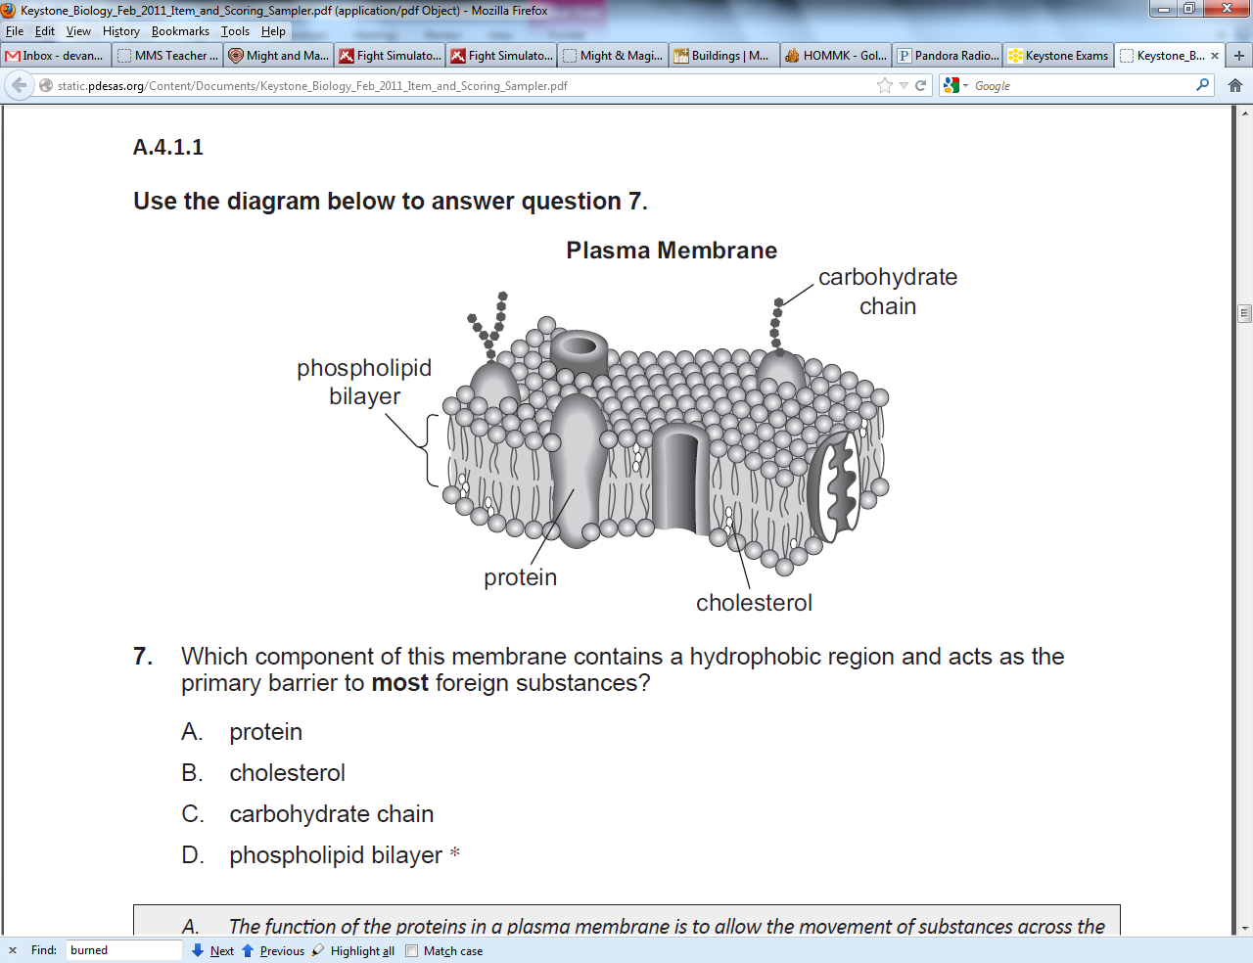Protein

Cholesterol

Carbohydrate chain

Phospholipid bilayer

1. Carbon dioxide and oxygen are molecules that can move freely across a plasma membrane. What determines the direction that carbon dioxide and oxygen molecules move?
   1. Orientation of cholesterol in the plasma membrane.
   2. Concentration gradient across the plasma membrane.
   3. Configuration of phospholipids in the plasma membrane.
   4. Location of receptors on the surface of the plasma membrane.
2. A sodium-potassium pump within a cell membrane requires energy to move a sodium and potassium ions into or out of a cell. The movement of glucose into or out of a cell does not require energy. Which statement BEST describes the movement of these materials across a cell membrane?
   1. Sodium and potassium ions move by active transport, and glucose moves by osmosis.
   2. Sodium and potassium ions move by active transport, and glucose moves by facilitated diffusion.
   3. Sodium and potassium ions move by facilitated diffusion, and glucose moves by osmosis.
   4. Sodium and potassium ions move by facilitated diffusion, and glucose moves by active transport.
3. The rough endoplasmic reticulum and Golgi apparatus work together in eukaryotic cells. What is one way that the rough endoplasmic reticulum assists the Golgi apparatus?
   1. It assembles nucleic acids from monomers.
   2. It breaks down old, damaged macromolecules.
   3. It packages new protein molecules into vesicles.
   4. It determines which protein molecules to synthesize.
4. Which example is an activity that a fish MOST LIKELY uses to maintain homeostasis within its body?
   1. A. Using camouflage to avoid predators.
   2. B. Feeding at night to regulate body temperature.
   3. C. Moving to deeper water to regulate metabolic wastes.
   4. D. Exchanging gases through its gills to regulate oxygen levels.

**CONSTRUCTED-RESPONSE QUESTION**

Proteins are a major part of every living cell and have many different functions within

each cell. Carbohydrates also perform numerous roles in living things.

**Part A:** Describe the general composition of a protein molecule.

**Part B:** Describe how the structures of proteins differ from the structures of carbohydrates.

**Part C:** Describe how the functions of proteins differ from the functions of carbohydrates.